JENKINS INSTALLATION PROCESS
Searched for AWS on google then signed in to AWS console then searched for EC2 then clicked on it and entered into dashboard-clicked on instance – gave a name for server - selected – Ubuntu-selected server – instance type – created akey- select https and http- lauched instance- it will be showing running then connected it to my vm machine terminal was opened. Updated machine with command sudo apt update- then installed java for Jenkins.- sudo apt install open-jdk- 8-jdk- -y –then checked java version java –version –googled pkg.jenkins.io – and got the pakage from their to install Jenkins the links were given in the google just copied and pasted in the terminal then at last Jenkins was installed.
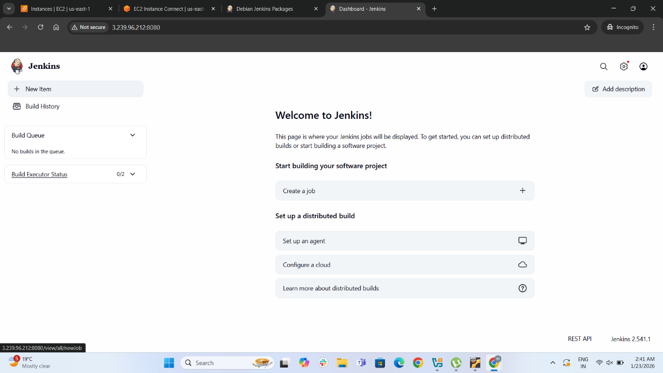

APACHE TOMCAT INSTALLATION PROCESS
Opened terminal on Ubuntu Java was already installed just clicked on sudo apt update-created a folder called opt for tomcat-saved in home directory-download tomcat from website apache tomcat official- copied tar.gz link and pasted in terminal with wget tar.gz- Then copied zip file of sha512 pasted in terminal wget sha512-then extracted the filw eith command xzvf apache-tomcat-10.1.50.tar.gz-file got installed-.start.sh –then added network settings to Ubuntu by netstat command-sudo ufw allow 8080/tcp to run on web server.typed in firefox http//:localhost:8080.
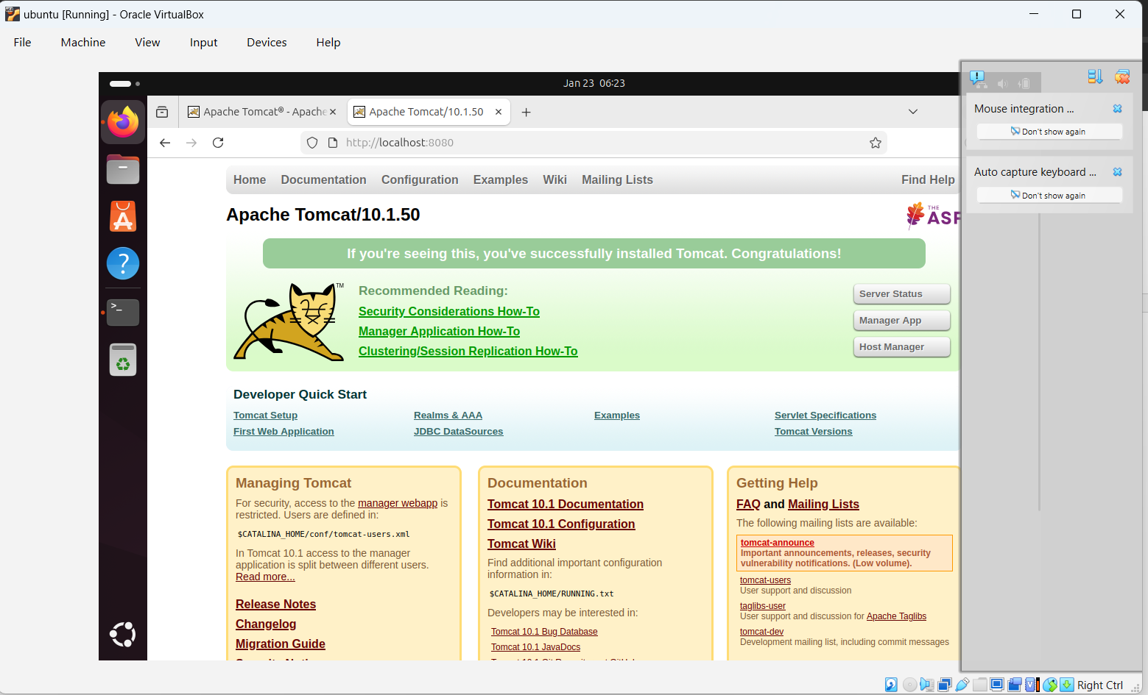

DOCKER INSTALLATION PROCESS
Just downloaded from google searched for docker for windows clicked on download selected windows and package got downloaded and I clicked on .exe file to execute the installation after some time it popup saying installation successful.
